University of Management and Technology
Assignment 03 Deliverable 01
Sequence Diagram
Name: Gulshan Parveen | ID: F2024065265
Course: Software Engineering | Section: W8
Instructor: Ma’am Kinza Sardar

Sequence diagram Of Sudoku Solver Game:
Use Cases:
01)Start Game
02)Enter a Number
03)Check for Valid Move
04)Undo move
05)Get Hint
06)Check Completion
Restart Game
Exit Game

For Each Use Case Sequence Diagram:
01)Start Game Sequence Diagram:
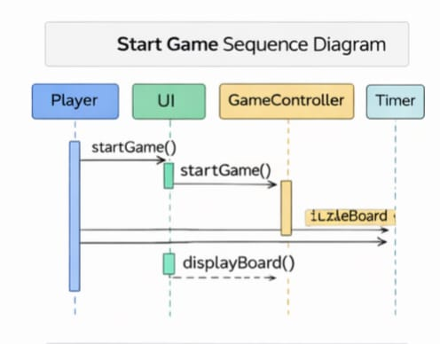
02) Enter Number Sequence Diagram:
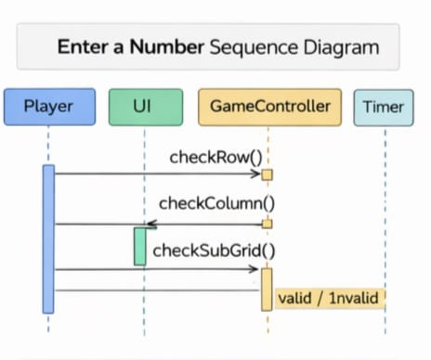

03)Validate Move Sequence Diagram:
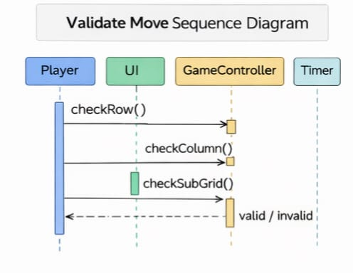
04)Get Hint Sequence Diagram:
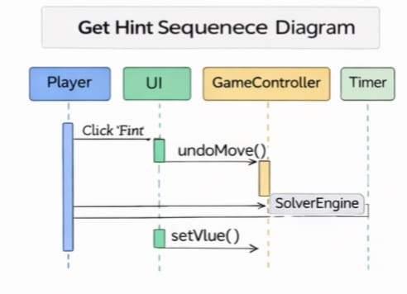

05)Check Completion Sequence Diagram:
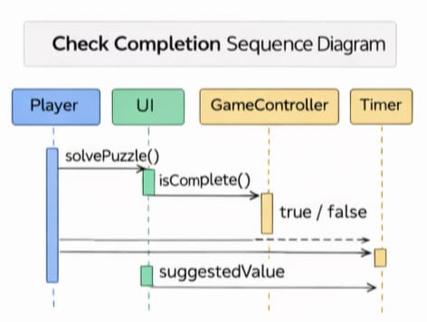

06)Undo Move Sequence Diagram:
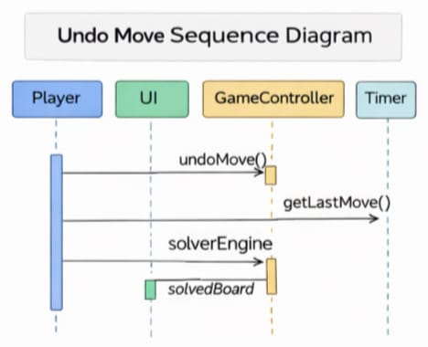

07)Restart Game Sequence Diagram:
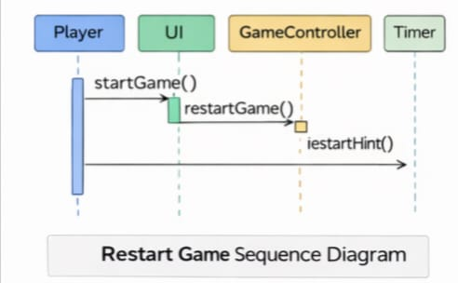

08)Exit Game Sequence Diagram:
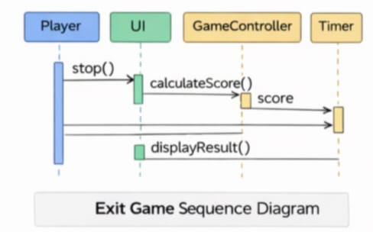

Complete Sequence Diagram:
